HEMORRHAGIC STROKE AFTER NAPHAZOLINE EXPOSITION – CASE REPORT
ACIDENTE VASCULAR ENCEFÁLICO HEMORRÁGICO APÓS EXPOSIÇÃO À NAFAZOLINA – RELATO DE CASO

Jorge A. A. Zavala¹, Eduardo R. Pereira¹, Viviane H. F. Zétola², Hélio A. G. Teive³, Édison M. Nóvak⁴, Lineu C. Werneck⁵.

Serviço de Neurologia, Departamento de Clínica Médica, Hospital de Clínicas, Universidade Federal do Paraná, Curitiba, Brasil.
(1) Médico Residente, (2) Médica Neurologista, (3) Professor Assistente, (4) Professor Adjunto, (5) Professor Titular.

Endereço para correspondência: Viviane H. Flumignan Zetola
R. General Carneiro 181, sala 1103. Curitiba, Brazil. CEP 80060-150.
Fone/fax: (41) 264-3606. e-mail: viviane@flumignano.com
Abstract
Ten percent of all strokes are due to spontaneous cerebral hemorrhages. They are associated to drugs (licit and illicit) in 9,5% of all cases in young adults. This is a case report of a 44-year-old man, without previous morbidities, who presented a sudden onset headache and arterial hypertension 24 hours after use of naphazoline as nasal decongestant. Cranial tomography showed right thalamus hemorrhage. Cerebral angiography showed no aneurisms, vascular malformations or vasculitis. No other risk factors were found during investigation in this patient and the stroke was attributed to naphazoline exposition.
Key words: hemorrhagic stroke, naphazoline, sympathomimetic drug.

Resumo
Dez por cento de todos os eventos vasculares encefálicos são devido às hemorragias intracerebrais espontâneas. Esses estão associados a drogas (lícitas e ilícitas) em 9,5% de todos os casos em adultos jovens. Relatamos o caso de um homem de 44 anos de idade, sem doenças prévias, que apresentou cefaléia súbita e hipertensão arterial 24 horas após o uso de congestionante nasal contendo nafazolina. A tomografia de crânio evidenciou hemorragia talâmica. Durante a investigação não foram encontrados outros fatores de risco e a hemorragia foi atribuída à exposição à nafazolina.
Palavras chaves: doença vascular encefálica hemorrágica, nafazolina, droga simpaticomimética.
Cerebrovascular diseases occur more frequently in elderly people. Peak incidence is between 7th and 8th decades [1,2]. Before age 55, incidence is 10% [3,4] and before 45 it falls to 3.9% [5].
Ten percent of all cerebrovascular events are due to hemorrhage [6]. Its estimated incidence in United States of America is 0.3/100,000 in younger than 35 years old [7]. Main etiologies are vascular malformations, arterial hypertension and exposition to drugs (amphetamines, sympathomimetics and illicit drugs) [8,9]. In young adults, drugs are associated to 9.5% of ischemic and hemorrhagic stroke [10].
We report a case of exposition to sympathomimetic drug naphazoline followed by thalamic hemorrhage.

Case repot
A 44 year-old previously healthy man, with no history of arterial hypertension, was admitted to the emergency department of Hospital de Clinicas, Federal University of Parana, complaining of headache and left arm weakness. Five days before he had had some flu-like symptoms and naphazoline nasal decongestant was prescribed. In the following day he had a sudden onset headache associated to nausea and vomiting. He then looked for medical attention. Blood pressure was 190/120 mmHg and captopril 50 mg as a single dose was prescribed. A couple of days latter he developed left hemiparesia that made him seek for our emergency department. There was no previous history of thrombotic disorders and there were no familiar stroke cases.
On physical examination vital signs were normal including blood pressure (120/70mmHg), with no positive signs on cardiopulmonary and abdominal examination. Neurological examination revealed an oriented patient, with intact memory and cognition. Cranial nerve examination showed no positive signs. There was left arm and leg hypotonia and slight weakness (4-/5). Babinski reflex was not present. He could stand up by himself and there was no gate disorders or cerebellar signs.
Cranial CT was performed and revealed thalamic hemorrhage of 2.1cm x 1.6 cm. The patient was admitted to the Neurologic Unit. Chemical constituents of blood and hematological exams as total cholesterol and fractions, fast glucose, tryglicerides, complete blood count, coagulation tests (hypercoagulable states from protein C, free protein S, antitrombin III, lupus anticoagulant and anticardiolipin antibody abnormalities) and inflammatory marks were negative (C-reactive protein, ESR). Electrocardiogram and echocardiogram were normal. Cerebral angiography revealed no aneurisms, vascular malformations or vasculitis (Figure 1). No drugs were needed to control blood pressure and the patient was discharged in the 8th day after admission with total recovery of the motor deficit.

Case discussion
Cerebrovascular diseases are example of medical conditions with multiple risk factors. Complete investigation of predisposing factors and exhaustive laboratory data performance are needed to find their cause. Even these efforts are not always sufficient and the diagnostic conclusion is made by exclusion. In younger patients it becomes more evident once vascular risk factors can be absent most of the time.
Most common causes of hemorrhagic stroke in young adults are vascular malformations, including cavernous angiomas, and arterial hypertension [11]. Risk factors are smoking and hypocholesterolemia. In 1984, Pentel described sympathomimetic drugs exposition as a risk factor for cerebrovascular disease [12]. Most common drugs associated to stroke were phenylpropanolamine, ephedrine, pseudo-ephedrine and caffeine leading to hypertension, hypertensive encephalopathy and hemorrhagic stroke. Sloan at al found a positive previous exposition to drugs in 11% of 116 cases of stroke between 1988 and 1989 [10]. There was no difference for hemorrhagic or ischemic stroke. Related substances were cocaine, heroine, sympathomimetic drugs and phencyclidine. Most recently, Morgenstern et al showed association between high doses of Ephedra in over-the-counter products for weight loss and energy enhancement and occurrence of hemorrhagic stroke [13].
Until 1992, 142 cases of hemorrhagic stroke associated to exposition to phenylpropanolamine as nasal decongestants have been reported [14]. Between 1969 and 1991, there were 22 spontaneous reports of such relation to the FDA.
In order to verify if association of phenylpropanolamine to stroke was true, Kernan and cols conducted a prospective study between 1994 and 1999 [15]. Association was positive for patients who used it as nasal decongestant for the first time and for woman who used it as appetite moderators. A possible mechanism for cerebral infarction is focal arterial vasoconstriction and occasionally cerebral vasculitis. A likely mechanism for intracranial hemorrhage is acute arterial hypertension. With the exception of endocarditis, management of stroke related to drug abuse is largely supportive, with emphasis on supportive care to prevent stroke complications, physical and occupational therapy, and aggressive addiction rehabilitation.
There are no other risk factors than exposition to naphazoline in the reported case above. No other similar cases were found in medical literature. Our conclusion is that as it is a sympathomimetic drug as phenylpropanolamine, it can lead to the same adverse reactions such as arterial hypertension and stroke.

References
- Sacco RL, Hauser WA, Mohr JP. Hospitalized stroke in black and hispanics in Northern Manhattan. Stroke 1991;22:1491-1496.
- Leno C, Berciano J, Combarros O, J. M. Pólo, Pascual J, Quintana F, Merino J, Sedano C, Martin-Duran R, Alvarez C et al. a prospective study of stroke in young adults in Cantabrio, Spain. Stroke 1993;24:792-795.
- Nencini P, Inzitari D, Baruffi MC, Fratiglioni L, Gagliardi R, Benvenuti L, Buccheri AM, Cecchi L, Passigli A, Rosselli A et al. incidence of stroke in young adults in Florence, Italy. Stroke 1988;19:977-981
- Zétola VHF, Nóvak EM, Camargo CH, Carraro HJr, Coral P, Muzzio JA, Iwamoto FM, Della-Coleta MV, Werneck LC. Stroke in Young adults: analysis of 164 patients. Arq Neuropsiquiatr 2001;59:740-745.
- Kristensen B, Malm J, Carlberg B, Stegmayr B, Backman C, Fagerlund M, Olsson T. Epidemiology and etiology of stroke patients aged 18 to 44 years in Northern Sweden. Stroke 1997; 28:1702-1709.
- J. P. Mohr JP, Caplan LR, Melski JW, Goldstein RJ, Duncan GW, Kistler JP, Pessin MS, Bleich HL. The Harvard Cooperative Stroke Registry: a prospective registry. Neurology 1978; 28:754-762.
- Drury I, Whisnant JP, Garraway WM. Primary intracerebral hemorrhage: impact of CT on incidence. Neurology 1984;34:653-657.
- Toffol JC, Biller J, Adams HP. Nontraumatic intracerebral hemorrhage in young adults. Arch Neurol 1987;44:483-485.
- Caplan L, Hier DB, Banks G. Stroke and drug abuse. Stroke 1982;13:869-872.
- Sloan MA, Kittner SJ, Rigamonti D, Price TR. Occurrence of stroke associated with use/abuse of drugs. Neurology 1991;41:1358-1364.
- Ruiz-Sandoval JL, Cantu C, Barinagarrementeria F. Intracerebral hemorrhage in young people. Stroke 1999;30:537-541.
- Pentel P. Toxicity of over-the-counter stimulants. JAMA 1984;252:1898-1903.
- Morgenstern LB, Viscoli CM, Kernam WN, Brass LM, Broderick JP, Feldmann E, Wilterdink JL, Horwitz RI. Use of ephedra-containing products and risk for hemorrhagic stroke. Neurology 2003;60:132-135.
- Lake CR, Gallant S, Masson E, Miller P. Adverse drug effects attributed to phenylpropanolamine: a review of 142 case reports. Am J Med 1990;89:195-208.
- Kernan WN, Viscoli CM, Brass LM, Broderick JP, Brott T, Feldmann E, Morgenstern LB, Wilterdink JL, Horwitz RI. Phenylpropanolamine and the risk of hemorrhagic stroke. N Engl J Med 2000;343:1826-1832.
Figures

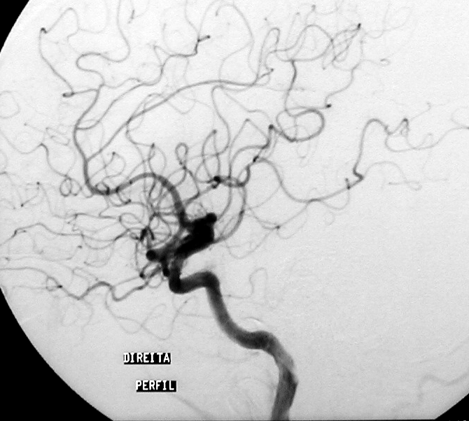
1A
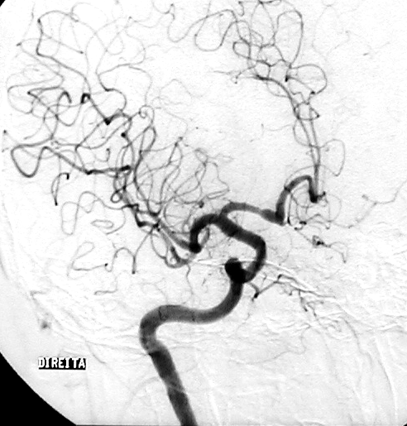
1B

Figure 1: Lateral (1A) and anterior view (1B) of cerebral angiography showing no aneurisms, vascular malformations or vasculitis.

Figure 2: Cranial tomography showing right thalamus hematoma.
